Economic Integration
Name
Institution Affiliation
Economic Integration
Economic integration entails two countries agreeing to allow the flow of capital, labor, goods, and services across their international boundaries to varying degrees. The theory of economic integration goes through two stages of development, each addressing the pertinent political and economic context for its time. The first stage is considered to be a classic theory or static analysis which consists of the traditional economic integration theories that illustrate the potential benefits of integration (UK Changing Inc, 2019). The second stage features new theories of economic integration, often alluded to as the dynamic analysis of economic arrangements. In addition to these two, there exists a third type of integration theories that address the impacts, advantages, and constraints of developing and least developed countries ' economic integration arrangements.
Implications of Economic Integration
Economic integration tends to lead to the redistribution of labor and capital moving towards better exploitation of labor and capital. Labor shifts to the higher - wage area, while capital shifts to the higher - wage area. The value-added pair of industries and labor disperses within a region in the same manner as heat or gas in space. In the member states of the economically integrated region, domestic savings rates aspire to the same scale as outlined by the economic block coherence policy.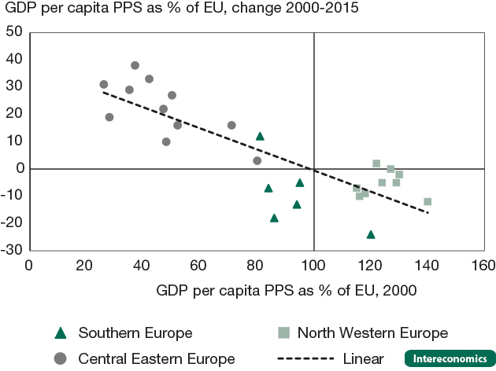
https://archive.intereconomics.eu/year/2019/1/economic-integration-and-income-convergence-in-the-eu/
Economic integration boosts economic growth, in particular, GDP, depends on the level of development and on the level of unifying states. For example, if two countries are economically integrated, the larger the size of the economy the less it gets from integration. The reverse is also true as there is increased productivity in the unified region. In developed countries, productivity tends to be more in countries that are less developed.
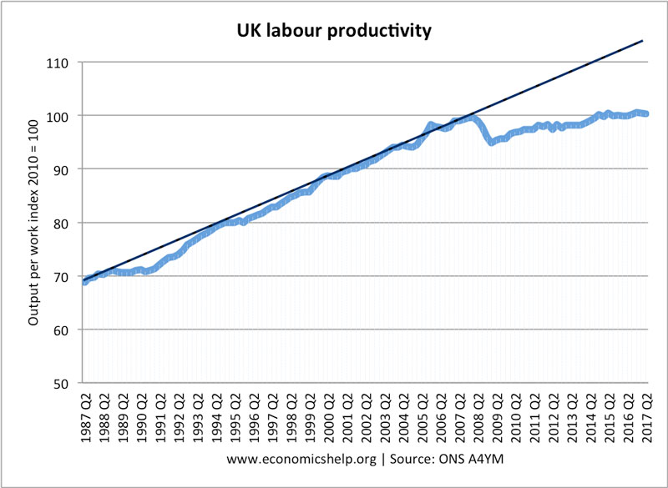
https://www.economicshelp.org/blog/5887/economics/uk-labour-productivity/
Free access to other Member States ' markets is another effect of economic integration. Regional funds are set up to redeploy revenue from more developed to less developed countries by supranational bodies of the Union. This means that equal development is ensured in member states. Buyers and sellers are free to move from one country to another provided you are within the member states boundaries. Buyers can sample new products from different countries without restrictions. The sellers also enjoy the opportunity of bringing on board new buyers from different countries. This wouldn’t have been possible if the countries had not economically integrated.
Trade diversion is another implication of economic integration. There are scenarios whereby a member country has to halt its operations with a non-member country because of trade barriers despite the lack of cost efficiency. Some of the rules of the union inhibit trade with non-member countries. Most of the lamb in the U.K was got from New Zealand before U, K joined the European Union. After Britain joined the EU, the common external tariff made imports from countries in the EU community less expensive in comparison to those from New Zealand, France became the UK's number one exporter of lamb. (The Global Economy, 2019). Erosion of national sovereignty is an outcome of economic integration.one of the requirements for one to be a member of a union entails that Economic union members are typically expected to conform to trade, monetary and fiscal rules established by an unselected external policymaking body. The greater the integration degree, the higher the level of control needed. European Union had agreed for free travel in the region, but then a lot of Tunisian Citizens had started to flock into Italy. Italian Prime minister couldn’t control this. So a motion had to be tabled in the European Union to limit the entry of Tunisians in Italy.
History of the European Union
The European Union is set up to end the frequent and bloody neighborhood wars that resulted in World War II. Belgium, France, Germany, Italy, Luxembourg, and the Netherlands are the six founding countries. In 1961, the United Kingdom applied for membership for the first time. It quickly became apparent that within Western Europe there was a political isolation threat, Commonwealth states were running straight to deal with the new Union, which had U.S backing. In 1963, the French government overruled this request with a second request rejected by the French again in 1967. Only in 1969 was the free pass offered to British membership negotiations. The United Kingdom joined Denmark and Ireland in the European Economic Community on 1 January 1973. That at the time was controversial. Initially, the Labor Party actively sought membership renegotiation. A referendum was held to determine if the UK was to remain a member of the Community. This referendum took place in 1975 where a vote of 67 percent in favor of the U.K to stay.
Reasons for Brexit
The United Kingdom wanted to ensure explicit acknowledgment that the euro is not the European Union's only currency. This is to make sure that none - Eurozone countries are substantially marginalized (Catherine Boyle, 2015). The United Kingdom wants safeguards that none - Eurozone members cannot take steps towards further financial union and the United Kingdom do not have to contribute to the bailouts of the Eurozone. Another reason is Setting an objective to ease the burden of overregulation and extend the Single Market.
Limiting access for EU migrants to work in and out - of - work benefits The ministers wish to block immigrants to the U.K from claiming certain benefits until they are four years in residence. It is reported that the UK's top executive warned ministers that this could be exclusionary and that any limits could be reduced a year or less. Lastly, U.K wanted to remain sovereign, making decisions on its own and not to have to consult member states before making decisions about U.K (BBC, 2016). Britain should not leave the European because financial firms based in the United Kingdom would lose the right to work freely throughout the continent. Brexit will lead to a reduction in immigration that could also damage skill shortages in the UK workforce. The best professionals from other countries will not come into U.K. The left vote will affect the rest of Europe because countries who would like to trade in the U.K will be imposed huge tariffs which will hinder them from trading in the United Kingdom.
Importance of International Trade
International trade gives a comparative advantage. Trade allows countries to specialize in goods where the cost of opportunity is relatively lower (Pettinger, 2019). When a country can produce fewer goods at a lower cost – that doesn't mean they ought to produce all. India can have a comparative advantage in production which is labor intensive with lower labor costs for instance in cloth making. Exporting these services and goods would be efficient for India. Although an economy such as the UK may have a comparative advantage in the production of education and video games. International trade makes it possible for countries to major on one good or service.
A wider range of goods is available for use. International trade brings a particular product from different destinations into different varieties. For instance, there are different wines from different countries in the E.U. France is the main exporter and other exporters include Hungary, Germany, and Portugal. Customers can enjoy the different varieties of wine offered in the market (Eurostat, 2018). German also specializes in vehicle manufacture. There are a variety of motor vehicle brands from Germany including Audi Series, BMW, Mercedes Benz, Porsche, and Volkswagen.

References
BBC. (2016, February). Q&A: What Britain wants from Europe. Retrieved from BBC: https://www.bbc.com/news/uk-politics-32695399
Catherine Boyle. (2015, May). Just what is the UK’s problem with Europe? Retrieved from CNBC: https://www.cnbc.com/2015/05/27/why-would-the-uk-want-to-leave-the-eu.html
Eurostat. (2018, December). Wine production and trade in the EU. Retrieved from Eurostat: https://ec.europa.eu/eurostat/web/products-eurostat-news/-/EDN-20181112-1
Kenton, B. A. (2019, March). Economic Integration. Retrieved from Investopedia: https://www.investopedia.com/terms/e/economic-integration.asp
Pettinger, T. (2019, March). The importance of international trade. Retrieved from Economics: https://www.economicshelp.org/blog/58802/trade/the-importance-of-international-trade/
The Global Economy. (2019, March). Trade Diversion. Retrieved from The Global Economy: https://www.theglobaleconomy.com/glossary/article/139/
UK Changing Inc. (2019, March). When did Britain decide to join the European Union? Retrieved from UK and EU: https://ukandeu.ac.uk/fact-figures/when-did-britain-decide-to-join-the-european-union/

